**Team Ace Domain Model**

The StudentUser is the main part of the domain model. The purpose of the application is to connect StudentUser to employers, mentors, and learning tools. The application will also allow the StudentUser to use generative AI tools to help with tone and content of professional emails and applications. The studentUser, EmployerUser, and MentorUser will be able to create accounts. The EmployerUser and MentorUser will be able to create listings for job opportunities/internships and mentorships respectively that will be stored in AvailableListings. The StudentUser will be able to access the AvailableListings and be able to filter for what they are looking for. The StudentUser will also be able to access AvailibleTools to access the LearningTools.

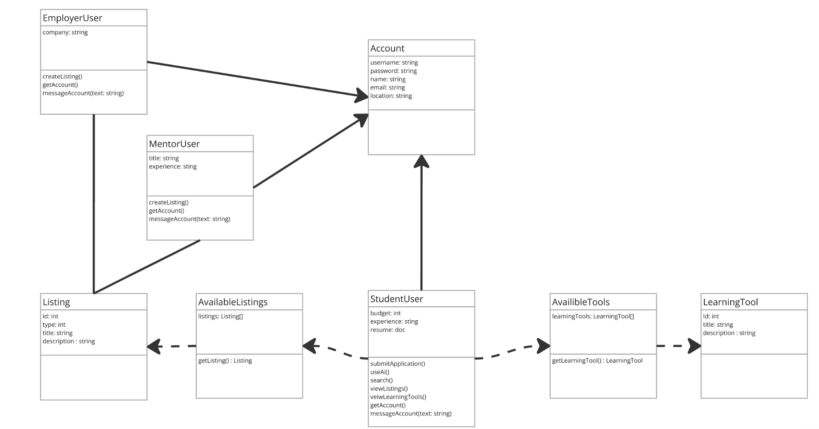

**Account**

-username: string

-password: string

-name: string

-email: string

-location: string

**StudentUser**

-budget: int

-experience: string

-resume: doc

-submitApplication()

-useAi(message: string) : string

-search(text: string)

-veiwListings()

-viewLearningTools()

-getAccount()

-messageAccount(text: string)

**EmployerUser**

-company: string

-createListing()

-getAccount()

-messageAccount(text: string)

**MentorUser**

-title: string

-experience: sting

-createListing()

-getAccount()

-messageAccount(text: string)

**Listing**

-id: int

-type: int

-title: string

-description : string

**AvailableListings**

-listings: Listing[]

-getListing() : Listing

**LearningTool**

-Id: int

-title: string

-description : string

**AvailibleTools**

**-**learningTools: LearningTool[]

-getLearningTool() : LearningTool